

DEPARTMENT OF COMPUTER SCIENCE AND ENGINEERING

Academic Year
2026 – 2027 (Odd Semester)

MINI PROJECT REPORT

U23CS454 Database Management Systems Laboratory

------ PROJECT TITLE -----

Submitted by, Mentored by,
[25CSXXX]
Name of the Student
Name of the Faculty
Designation,
Department of <deptname>

 | TABLE OF CONTENTS
CHAPTER NO. | TITLE |  |  |  | PAGE NO.
 | ABSTRACT |  |  |  | i
 | LIST OF TABLES |  |  |  | ii
 | LIST OF FIGURES |  |  |  | iii
1 | INTRODUCTION
 | 1.1 |  | OBJECTIVES
 | 1.2 |  | SCOPE OF THE PROJECT
2 | SYSTEM ANALYSIS AND SPECIFICATION
 | 2.1 |  | PROBLEM DESCRIPTION
 | 2.2 |  | FUNCTIONAL REQUIREMENT -  HARDWARE & SOFTWARE
 | 2.3 |  | NON – FUNCTIONAL REQUIREMENT
3 | SYSTEM DESIGN
 | 3.1 |  | ER DIAGRAM
 | 3.2 |  | SCHEMA DIAGRAM
4 | PROPOSED SOLUTION
 | 4.1 OVERVIEW |  | USER INTERFACE DESIGN
 | 4.2 |  | CLASS CONSTRUCTION
 | 4.3 |  | DATABASE CREATION
5 |  | PROJECT DESCRIPTION
 |  | 5.1 |  | <<MODULE DESCRIPTION – Use your own Module Name>>
 |  |  |  | <<Add your module Description numbered like 5.1.1, 5.1.2, 5.1.3, etc >>
 |  | 5.2 |  | JDBC CONNECTIVITY
6 |  | IMPLEMENTATION
7 |  | RESULTS AND DISCUSSION
8 |  | CONCLUSION & FUTURE ENHANCEMENT
 |  | REFERENCES

ABSTRACT

Add the abstract of your project in 300 words in one paragraph here

 | LIST OF TABLES
S.NO | TITLE | PAGE NO.
 | Product Table
 | Inventory Table
 | Supplier Table
 | Transaction Table
 | Inventory Transaction Table
 | Product_Supplier Table
 | Transaction_Log Table

 | LIST OF FIGURES
S.NO | TITLE | PAGE NO.
 | Schema Diagram
 | Entity Relation Diagram (ERD)
 | Use Case Diagram
 | Class Diagram
 | Title of the output screenshot1
 | Title of the output screenshot2
 | Title of the output screenshot3
 | Title of the output screenshot4

CHAPTER 1
INTRODUCTION

  - OBJECTIVES

  - SCOPE OF THE PROJECT

CHAPTER 2
SYSTEM ANALYSIS AND SPECIFICATION

2.1 PROBLEM DESCRIPTION

2.2 FUNCTIONAL REQUIREMENT –
SOFTWARE AND HARDWARE REQUIREMENTS

2.3 NON-FUNCTIONAL REQUIREMENT

CHAPTER 3
SYSTEM DESIGN

3.1 ER DIAGRAM
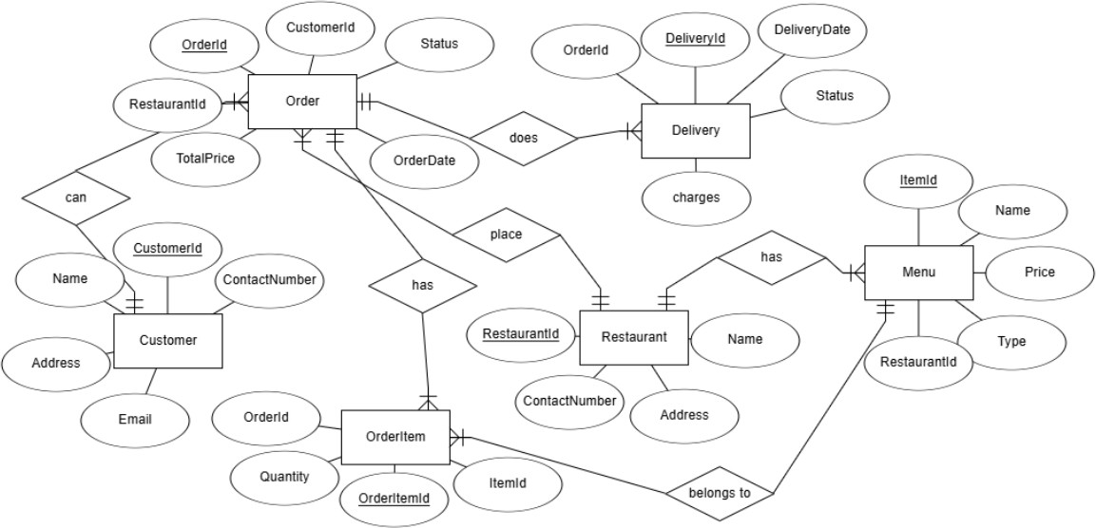
3.2 SCHEMA DIAGRAM

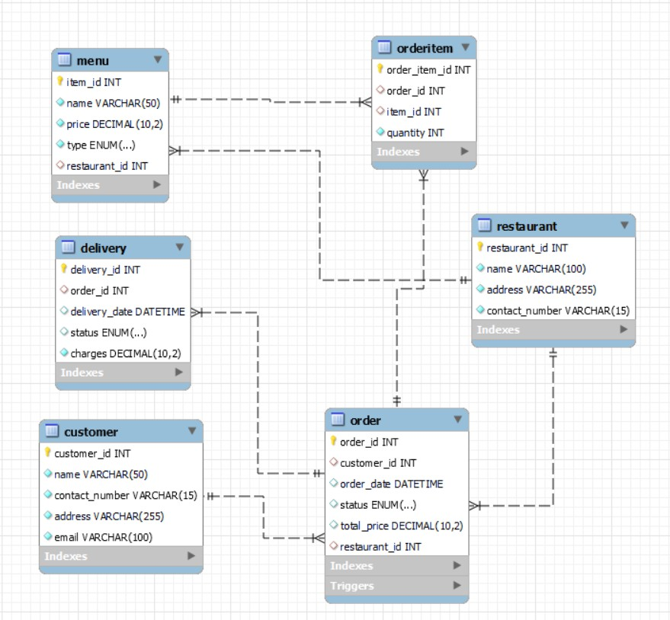

CHAPTER 4
PROPOSED SOLUTION

4.1 USER INTERFACE DESIGN
Draw the diagram according to the functionalities given.
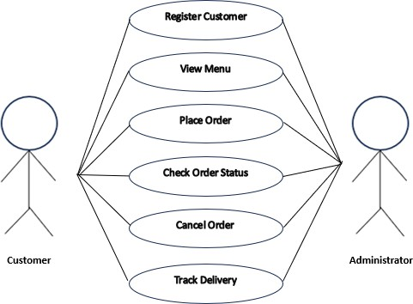

4.2 CLASS CONSTRUCTION

4.3 DATABASE CREATION

Include the MySQL Codes for the table creation

CHAPTER 5
PROJECT DESCRIPTION

5.1 MODULE DESCRIPTION
5.1.1 <<Add your module Description>>
5.1.2
5.1.3

5.2 JDBC CONNECTIVITY
Include the MySQL Connection code here

CHAPTER 6
IMPLEMENTATION

Include your entire code here

CHAPTER 7

RESULTS AND DISCUSSIONS

Paste your screenshots along with the Description.

CHAPTER 8
CONCLUSION AND FUTURE ENHANCEMENT

REFERENCES

[1] https://youtu.be/C-KZO_dLr-A
[2] https://www.codewithharry.com/videos/python-tutorials-for-absolute- beginners-120
[3] https://github.com/Ram-Deepak/Natasha.git
[4] https://towardsdatascience.com/how-to-build-your-own-ai-personal-assistant-using-python-f57247b4494b?gi=847571c7aacd
[5] https://youtu.be/tSjR7bk1Y9U

